Return on Investment Analysis of Georgia’s Afterschool Programs
Prepared by Justin Ingels for the Georgia Statewide Afterschool Network
Justin Ingels is the Research Director for the Economic Evaluation Research Group and an Assistant Research Scientist of Health Policy and Management at the University of Georgia

Overview
The goal of the analysis addressed in this document is to answer the following question:
What is the return on investment (ROI) for Georgia’s afterschool programs?
Or another way of stating this question:
For every dollar invested in Georgia’s afterschool programs, how many dollars are returned to the state?
To this end, several questions must be addressed, including the following:
- How many students participate in Georgia’s afterschool programs and what proportion are regular participators?
- How much does it cost to provide Georgia’s afterschool programs?
- What impact on graduation rates is expected from participation in afterschool programs?
- How much do the state and taxpayers benefit in the short- and long-term from this participation?
The first two questions are essential for converting the total annual investment that is currently made to Georgia’s afterschool programs to a cost per participating student. The published literature indicates that most of the benefits will be accrued by those students that participate at a minimum level. Therefore, a distinction is made between all participators and regular participators for purposes of estimating per student benefits. The improvements in school performance and engagement that are documented through regular participation connect to a reduced risk for dropping out later in a student’s academic life, thereby increasing the graduation rate in the state. This increase in the graduation rate is critical for estimating some of the most important benefits of these programs. Finally, additional short-term and long-term benefits for regular participators will be estimated and valued based on savings to the state/taxpayer.
For the reference case analysis outlined below, care has been taken to only consider direct monetary benefits to the state/taxpayers expected from the investment in afterschool programs. This is done for two reasons:
- Whether these programs are paid for through federal grants, as is currently the case or the funding is provided by the state, taxpayers face the burden for these costs.
- These other individual and societal benefits are typically much larger in value than when the perspective is restricted to the state/taxpayer. Therefore, if a positive net benefit were found in this more restricted perspective, the assumption would be that the net benefits are even larger to society as a whole.
One significant challenge with this analysis is the use of cross-sectional rather than longitudinal data. The benefits of afterschool programs will not result from a single year of participation in a program but rather from several years of participation. Published research suggests three to five years of regular participation are needed to realize positive benefits (Goldschmidt, Huang et al. 2007). Therefore, the analyses will assume that an investment is made in Georgia’s afterschool programs over a number of years and only regular participators will benefit from the program. This is designed to be a conservative estimate of the ROI by potentially underestimating the total benefit produced by these programs. Care will be taken to use conservative estimates of both the magnitude and value of each benefit included in the analysis, potentially further deflating the benefit expected for regular participators. If a positive return on investment is found, these assumptions will lend greater validity to the idea that there is truly a positive return to investment in afterschool programs and that the numbers provided are a lower bound on this potential return. In sensitivity analyses, these assumptions will be relaxed to demonstrate how large the ROI may actually be for investment in Georgia’s afterschool programs.

Common Terminology
The following terms and acronyms will be used throughout this report for purposes of clarity.
ROI | A return-on-investment analysis is a type of benefit-cost analysis where the investment in a program is compared to the benefits of a program expressed in dollar terms (economic returns). These economic returns are limited to those that directly benefit the investor in the program, excluding benefits limited to the participants or that accrue to society in general.
CCLC | Refers to Georgia’s 21st Century Community Learning Centers Program administered by the Georgia Department of Education (GaDOE), a combination of afterschool, before school, and summer programming funded by the federal government.
ACP | Refers to the Afterschool Care Program administered by the Georgia Division of Family Children and Services (DFCS) funded through some of Georgia’s Temporary Assistance for Needy Families (TANF) dollars
Regular Participator | A regular participator will be defined as any student that participates at least 3-4 days a month or 30 days in a year.
BGCGA | The Georgia Alliance of Boys and Girls Clubs.

Methodology

Summary of Analysis
The costs of afterschool programs in Georgia are straightforward to estimate as they consist primarily of the federal funding provided for these programs and any additional resources utilized by local schools providing the programs. It is impossible to disentangle the impacts of a program from other outside factors or other programs that participating students may be likely to participate. Longitudinal studies that follow a comparable group of participating and non-participating students would be ideal for this purpose but only one published study is available (Goldschmidt, Huang et al. 2007). Therefore, this analysis must rely on studies of afterschool programs that have limited data and other types of intervention programs that do have results from well-designed longitudinal studies.
This analysis makes a comparison between the expected experiences of students with and without access to a high-quality afterschool program. This comparison is made in the present and, therefore, the timing of costs and benefits that do not occur entirely in the present must be taken into account. Future cost and benefit streams are discounted to reflect the fact that the amounts spent or saved in the future should not weigh as heavily in decision making as those spent or saved today. This is primarily due to the existence of time preference, as a society we prefer to have money or resources now, as opposed to later, because we could benefit from them in the interim. Therefore, for the base case analysis, a discount rate of 5% will be used to discount future costs and benefits and the impact of other discount rates will be considered in sensitivity analyses (ranging from 3% to 7%).
Two final issues to consider are the distribution of students in afterschool programs by grade level and the gradation of engagement within regular participators. First, some benefits, such as the prevention of juvenile crime, are far more likely to occur for older students than for younger students. Therefore, this analysis will consider the distribution of students by elementary, middle, and high school and certain benefits will only accrue to the sample of students in one or two of these age groups. Second, the highest-quality study of afterschool programs found that regular participators classified as having medium or high engagement showed a benefit in terms of reduced juvenile crime while those regular participators classified as having low engagement showed no benefit. Therefore, in this analysis, some benefits will only accrue to those regular participators classified at medium or high engagement. The participation data available for this analysis is stronger for CCLC with number of participation days reported directly for each child than ACP where it is reported at the aggregate by month. Similarly, grade is reported directly for each child by CCLC but at an aggregate level for ACP, that only allows a separation between elementary-aged and older students. An assumption is made that the older students are split evenly between middle school and high school, similar to the CCLC sample.
Concerning timing, this analysis will estimate the investment needed, per student, to provide afterschool programming for three years to regular participators. For some students, year 1 will be defined in elementary school, for others in middle school, and for the rest in high school. For the timing reasons outlined above, these three periods will serve as the present time to which future costs and benefits will be discounted. Further, cost and benefit estimates provided throughout the methodology are per student, not per episode prevented (such as dropout or teen birth prevented). For example, if a benefit was expected to accrue to one in five of the participators, the value of that benefit per student is presented as one-fifth of the value related to the episode.

Addressing the Key Research Questions
The following sections will detail how each research question outlined above was addressed. Included throughout are example calculations to help clarify each piece of the final analysis.

How many students participate in Georgia’s afterschool programs and what proportion are regular participators
To realize the benefits of Georgia’s afterschool programs, students must regularly participate in the afterschool program. There are expected to be many more students participating for at least one day during a given academic year than actually participate regularly throughout the year. As mentioned above, this analysis assumes that some regular participation is needed to realize any of the benefits attributed to afterschool programs. Therefore, for the reference case analysis the current definition used by CCLC of a regular participator, 30 days in a year, will be used to define regular participation. This is a similar threshold for participation used in other published studies. As this is a somewhat arbitrary definition as it relates to the realization of benefits, in a sensitivity analysis, different definitions of regular participator will be tested to determine the impact of this assumption on the results. Further, an engagement level scheme will be applied to the regular participators where low engagement includes those that participate four to nine days per month, medium engagement includes those that participate 10 to 14 days per month, and high engagement includes those that participate 15 days or more per month (Goldschmidt, Huang et al. 2007). These definitions were used in the study of LA’s BEST afterschool program and correlated with better academic achievement and reductions in criminal justice. Attendance data provided for CCLC and ACP students differed from how engagement was defined in LA’s BEST. Table 1 outlines how engagement level was defined for each of these sources. For ACP, this data was not available for all ACP students but only for students of families who are registered members of the Georgia Alliance Boys and Girls Club (BGCGA), a subset of the full sample (88% of all students). Registered members are a further subset of this 88 percent with 72% of income eligible youth being registered members (45,720 out of 63,612).
Table 1: Definitions of low, medium, and high engagement based on data source.
 | Regular Participator
 | Not a Regular | Yes
 | Participator | Low Engagement | Medium Engagement | High Engagement
LA’s BEST | <4 days/month | 4-9 days/month | 10-14 days/month | >14 days/month
CCLC | <30 days total | 30-89 days total | 90-134 days total | >134 days total
ACP | <1 day/week | 1-2 days/week | 2-3 days/week | 3+ days/week
Box 1. Total Number of Participating Students and Regular Participators

Based on the information in the FY2016 Executive Summary for Georgia’s 21st CCLC (Georgia DOE 2016), there was a total enrollment of 27,139 youth. Based on data provided by ACP, in FY2016 there were 72,191 youth served in afterschool programs without a breakdown of the number of regular participators.
F
27,139 + 72,191 = 99,300 total participating students

As a definition for regular participation, students with an attendance of at least 30 sessions are defined as regular participators. The aforementioned executive summary reported 20,637 regular participators for CCLC. In contrast, BGCGA provided monthly estimates of the proportion of students with weekly attendance of less than a day, one to two days, two to three days, and more than three days. Of the 72,191 participating students, 25,541 are defined as regular participators.

Based on BGCGA data, 35% of students attended at least once per week, providing an estimate of the number of regular participators for ACP.

20,637 + 25,541 = 46,178 regular participating students or 43% of all participating students

A further breakdown of participation is made into low, medium, and high engagement levels. Table 2 provides a breakdown by CCLC and ACP and engagement level. The Appendix provides a further breakdown of attendance in CCLC.

Table 2: Breakdown of engagement level by afterschool program.
 |  | Regular Participator
 | Not a Regular Participator | Low Engagement | Medium Engagement | High Engagement
CCLC | 6502 | 8410 | 7548 | 4679
ACP | 46,650 | 4808 | 6360 | 14,373
Total | 53,152  (53.5%) | 13,218  (13.3%) | 13,908  (14.0%) | 19,052  (19.2%)

How much does it cost to provide Georgia’s afterschool programs?
The measurement and valuation of costs for programs is often much easier than the measurement and valuation of the benefits of these programs. However, there are two potential issues:
- Participating students are unlikely to realize the benefits of afterschool programming based on a single year of participation.
- The total expenditures from the grant may not reflect all of the resources needed to implement the programs.
A cost per student based on one year of investment and the number of participating students provided above represents a single year of participation in an afterschool program. However, to realize the benefits associated with afterschool programs, a student likely needs to have regularly participated through several years to benefit. A detailed analysis of participation in afterschool programming in Los Angeles looked at some educational and juvenile crime outcomes by level of engagement (Goldschmidt, Huang et al. 2007). This study found that students who participate for at least two to three years experienced positive benefits relative to a control group. Therefore, without additional information regarding typical trajectories of participation across multiple years for participating students, we will assume in this analysis that students participate and accumulate the costs of the program for three years and that only regular participating students participate for multiple years and subsequently accumulate the benefit.
There are other resources beyond grants provided for participating CCLC or ACP sites, typically in the form of matching agency dollars. These additional expenditures will be included in the total cost per student estimate. Additionally, other resources without a direct monetary value are often utilized as well such as donated space and volunteer time. However, as this analysis is limiting the benefits to those of the state or taxpayer rather than taking a broader societal perspective, these broader societal costs will not be incorporated into the analysis.
Box 2. Afterschool Program Costs

Cost estimates for CCLC are based on the 2015-2016 Executive Summary of Georgia’s CCLC provided by Georgia DOE (2016). In this report, the total grant amount was $39,441,669 and programs contributed $14,552,374 worth of in-kind services and funding. Separate analyses of program contributions by category allowed for an estimate of 17.7% of these are financial costs (not donations or volunteer time). The total cost for CCLC is $42,017,439.

Cost estimates for ACP were provided directly and include $15,244,000 in grant funding and $37,883,250 in matching funds from local agencies. However, ACP could not delineate these funds into in-kind services and financial funding and an assumption will be made that 17.7% of these are financial costs (as found in the CCLC data). The total cost for ACP is $21,949,335.

The total combined cost of the two programs is $63,966,774

The cost per participating student is

($42,017,439 + $21,949,335) / 99,330 = $644 per student per year

Assuming the annual cost per student is $644, the total afterschool program costs over 3 years with a 5% discount rate has a present value of $1841 in financial costs for three years of afterschool programming per student.

In the sensitivity analysis, the assumption of the number of years students participate to produce effects (3 years) will be varied from 2 to 4 years.

How much do the state/taxpayers benefit in the short-term and long-term from this participation?
Some of the benefits of afterschool programs are realized in the short-term or soon after participation. For example, if the program reduces teen violence and property crimes, the savings will be felt immediately. If a program lowers truancy, the schools may realize savings in a number of ways including the administrative burden of dealing with truants. The schools may also experience reduced costs if grade retention is reduced because of better attendance. If teenage pregnancy rates are reduced, some of the economic benefits are realized immediately. However, the largest economic benefits occur in the long-term and are directly related to improved school performance and graduation rates. Better academic performance and likelihood to graduate from high school are associated with increased lifetime earnings, higher tax payments, reduced dependence on the welfare system, and a reduced likelihood of interaction with the criminal justice system. In the following sections, each of the short- and long-term benefit categories will be discussed.

What impact on graduation rates is expected from participation in afterschool programs?
In Georgia, a student can drop out of high school at age 16 (O.C.G.A. 20-2-690.1) and most students reach this age in the 10th or 11th grade (though grade repetition means that some students reach this age as early as 9th grade). This implies that preventing a student from dropping out of high school will result in an additional one to three years of education (beyond the dropout year). The graduation rate in Georgia was reported by the Department of Education to be 80.6% in 2017 for a dropout rate of roughly 19.4% (Georgia DOE 2017). However, students that participate in afterschool may have higher or lower baseline graduation rates. This is an important distinction as an estimate of the improvement in the number of students graduating based on relative changes in the dropout rate will be influenced by the estimate of the baseline dropout rate. Therefore, using graduation rate data available online from the Georgia Department of Education (2017), the expected baseline graduation rate was adjusted. Analysis of this data found that the ratio of the graduation rate for students defined as low socioeconomic status to the graduation rate for all students was 0.953.
Two studies of afterschool and related programs found that the dropout rates for program participants were between 1.5 and 2.0 times smaller than the dropout rates for a comparable group of children (Schweinhart 1993, Lattimore, Grotpeter et al. 1998) and similar analyses have used this assumption (Brown, Frates et al. 2002, MOST Network 2014). These programs were not targeted to older students but rather suggest that improvements in graduation rates could occur for regular participators of any age.

Box 3. Increased Graduation Rate

The most recent graduation rate in Georgia is 80.6% and the ratio of graduation rates for economically disadvantaged to all students is estimated to be 0.953.

80.6% * 0.953 = 76.8% graduation rate for economically disadvantaged students

If the expected dropout rate for regular afterschool participators without participation in an afterschool program is 23.2% (100% - 76.8%) and participation is assumed to reduce the dropout rate by 50% (i.e., 1.5 times lower for participators) then afterschool programs will increase the probability of graduating for regularly participating student by 11.6%.

23.2% * 50% = 11.6% increase in graduation rate

Another way of stating this increase is that without afterschool programming, 76.8% of these students would be expected to graduate while with afterschool programming, 88.4% of these students are expected to graduate.

An argument could be made that the relative reduction in the dropout rate for high school participators would be even greater than 50%. However, the students participating in high school are still in high school and are probably less likely to dropout. Therefore, the overall benefit may be similar.

In the sensitivity analysis, the baseline reduction in the dropout rate (50%) will be varied from 30% to 70%. Further, the baseline adjustment of the graduation rate for economically disadvantaged students (0.953) will be varied from 0.906 (double the adjustment) to 1.0 (no adjustment).

Reduced Juvenile Crime
The longitudinal study of LA’s BEST found the strongest short-term benefit of afterschool program was in the reduction of juvenile crime (Goldschmidt, Huang et al. 2007). As the engagement level of the students increased, the researchers found a greater reduction in the probability of juvenile crime for these regular participators. In this study, the costs associated with reducing juvenile costs were based on the work of Cohen (1998) and included victim costs, direct costs of adjudication, and probation. The low cost estimates of avoided crime costs per student were $1106 and $1802 annually, for medium and high engagement participators, respectively. Juveniles in Georgia have arrest rates across categories that are similar to those in California, the location of the aforementioned study (OJJDP 2016). This benefit from reduced juvenile crime is most likely to occur during a student’s middle and high school years and is considered a short-term benefit, associated with current participation in the program. For example, according to the Office of Juvenile Justice and Delinquency Prevention (2014), 63% of violent crimes committed by juveniles occur on school days with roughly one-third of those occurring during the standard afterschool hours.
Box 4. Reduced Juvenile Crime

Adjusted to 2016 US$, the avoided crime costs per student for medium and high engagement participators are $1628 and $2653, respectively. Assuming a distribution of regular participating students by engagement level of 53.5%, 13.3%, 14.0%, and 19.2% for non-regular participators and low, medium, and high engagement, respectively.

(14.0% * $1628) + (19.2% * $2653) = $737

This estimate would only be valid if students at all ages were expected to benefit from this program while participating, however, only middle and high school students (30.6% of all students) are expected to benefit.

(15.4% + 15.2%) * $737 = $226 per student per year

With a 5% discount rate across three years of regular participation, reduced juvenile crime has a present value of $645 per student in reduced costs from crime.

In the sensitivity analysis, the juvenile crime savings will be varied from a reduced benefit where medium engagement students are excluded from benefitting to an increased benefit where low engagement students are included in the benefit.

Increased Schooling Costs
An improvement in the graduation rate leads to additional expenditures for the state of Georgia. The average expenditure per student in 2016 was $9202 (Downey 2016). However, due to economies of scale, the cost of an additional student to the educational system is not expected to be this large. One study estimated the additional cost to be roughly 32% of the cost per student (Brown, Frates et al. 2002). Therefore, an estimate of $2944 per student was used for additional education costs per year.
Box 5. Example Calculation: Increased Schooling Costs

If students are equally likely to drop out in the 9th, 10th, and 11th grades, the average number of years of additional schooling per dropout prevented is 1.5 years.

Assuming an additional $2944 in educational costs per year, an 11.6% increase in the graduation rate, and 46.5% of students as regular participators, afterschool programs are expected to cost the state an additional $159 per student annually.

11.6% * $2944 per year * 46.5% = $159

For this analysis, we use an assumption of even distribution of dropouts across their first three years of high school. Therefore, one-third of students will each add an additional 1, 2, and 3 years of schooling, for an average of 1.5 years. With a 5% discount rate, increased schooling costs has a present value of $218 per student in increased schooling costs.

In the sensitivity analysis, the baseline adjustment to the additional annual education costs (32%) will be varied up and down by 20% (12% to 52%).

Reduced Grade Retention Costs
One result of better school attendance is a reduction in grade retention. The National Center for Education Statistics estimates that roughly 2.2% of elementary and secondary students are retained each year. In this analysis, we will assume there is a 2.2% chance of grade retention each year for a student that does not participate in afterschool programs through eighth grade (NCES 2017). A study done in 2002 on California’s After School Learning and Safe Neighborhoods Partnership Program concluded that regular participation in expanded learning opportunities could reduce a student’s risk of retention by 53.4% (Bissell and Malloy 2002). Therefore, the risk of retention in any given year is reduced by 53.4% for regular participators. This benefit seems to carry beyond the participation in the program and will be applied to regular participators through eighth grade.
CCLC reported a retention rate of 9% for all participating students with a roughly 13% rate for students who did not regularly participate and a roughly 6% retention rate for students that do regularly participate. This reduction in retention rate is similar to that in the 2002 student mentioned above. However, the base retention rate is much higher which has the potential for a higher absolute reduction in retention and a greater annual savings in grade retention costs. While the present value of the base case reduced grade retention costs with a 2.2% retention rate (Box 6 below) is $90, with a higher retention rate based on CCLC data, the total estimated reduction in costs increases to $534. See the Appendix for a further breakdown of grade retention from the CCLC program data.
Box 6. Example Calculation: Reduced Grade Retention Costs

Assuming the risk of retention in any given year for a student without the afterschool program is 2.2% and a reduction in this risk of 53.4% for regular participators, the updated risk of retention is 0.952% and the reduction in the probability of retention is 0.89%.

2.2% * 53.4% * 42.7% = 0.50%

Therefore, in any given year, assuming per student educational costs of $2944 (see Box 5), the savings per student is estimated to be $16.

0.55% * $2944 = $16

Over the remainder of elementary and middle school for the regular participators, the present value of this estimate using a 5% discount rate is $90 in reduced grade retention costs per student.

In the sensitivity analysis, the baseline retention rate (2.2%) will be varied to the CCLC data level of 13%. The reduction in retention rate will not be tested, as the CCLC data seemed to confirm the literature estimate. The adjustment to the annual education costs described above (see Box 5) will also affect these estimates.

Drug and Alcohol Addiction
Afterschool supervision can reduce the risk of addiction to drugs and alcohol by half (Newman, Fox et al. 2000). This can be used to estimate a reduction in the number of students that will be addicted. A national study found that the annual costs of substance abuse in the juvenile justice arena on the national level are $14 billion based on 2 million high school students currently addicted to substances (CASA 2011). Using these numbers, a crude estimate of the cost per addicted student to the taxpayer is $7000. Based on estimates of substance abuse and the proportion that meet the definition of addiction, the risk of addiction during teen years is 11%. With regular participation in afterschool programs, the risk for these youth can be expected to drop by half, reducing the risk by 5.5%. This benefit is expected to primarily occur for high school students.
Box 7. Reduced Teen Alcohol and Drug Dependence

Assuming a reduced risk of 5.5% of drug and alcohol dependence for regular participators, 19% of participating students were in high school, and a cost to taxpayers of $7469 (2016 US dollars) per dependent teen, the estimated annual savings from reducing dependence is $36. Finally, assuming three years of benefit and with a 5% discount rate, the present value of this benefit is $83 in reduced alcohol and drug dependence costs per student.

In the sensitivity analysis, the baseline risk of teen addiction is 11%.

Net Fiscal Contributions
For many childhood intervention programs, the biggest potential cost savings is related to crime prevention. Individuals who earn higher incomes because of graduating from high school are much less likely to need assistance from social programs. These two benefits, reduced crime and welfare program reliance could be treated separately, however, one recent study specifically considered the combined impact of these benefits tied directly to high school graduation (Sum, Khatiwada et al. 2009). An analysis by education level of the fiscal impact of individuals found that the average high school dropout will cost taxpayers over $292,000 (2007 US dollars) in lower tax revenues, higher cash and in-kind transfer costs, and imposed incarceration costs relative to an average high school graduate. When discounted at 5% and adjusted for inflation to 2017 US dollars, the present value is $69,002 assuming the costs are evenly distributed from age 18 to 64.
Box 8. Net Fiscal Contributions

Assuming a present value for the net fiscal impact of $69,002 over a working lifetime for someone who gets a high school diploma rather than dropping out, there is $4259 in net savings from increased tax payments and reduced welfare benefits and criminal justice costs per student.

In a sensitivity analysis, the present value for the net fiscal impact will be varied by 20% in either direction ($55,202 to $82,802) and the low engagement students will be excluded from benefitting (only the proportion that are medium and high engagement will be included).

Results

Return on Investment for the Afterschool Investment
Using the costs and benefits related to Georgia’s afterschool programs outlined above, there are two relevant summary measures.
- Net present value (NPV) is the difference between the present value of benefits and the present value of costs. A positive value indicates that the benefits are greater than costs and that there are savings expected from the state or taxpayer’s perspective.
- Benefit-cost ratio (BCR) is the ratio of the present value of benefits and the present value of costs. A value greater than one indicates expected savings (in line with a positive net present value). Further, this number represents the number of dollars in benefits expected for each dollar invested.
These two summary measures are shown in Table 3 using the results of the analysis described above.
Table 3: Base case analysis results of the return on investment analysis.
Base Case Analysis: State/Taxpayer Perspective
Costs |  |  |  | Benefits
 | Investment in afterschool program | $1841 |  |  | Reduced juvenile crime | $645
 | Increased schooling costs | $218 |  |  | Reduced grade retention | $90
 |  |  |  |  | Reduced drug and alcohol dependence | $83
Total Costs |  | $2059 |  |  | Net fiscal impact on taxpayers (adult years) | $4627
 |  |  |  | Total Benefits |  | $5445
Net Present Value |  | $3386
Benefit-Cost Ratio |  | $2.64

The benefits are realized as dollar savings or added revenues for government. Thus, it is possible to compare the public benefits to the financial costs of the program in order to get a sense of the overall fiscal impact of the program. Based on the estimates in Table 3, these benefits amount to $5445 per participating student, this benefit is $3386 greater than the investment made in afterschool programs per student. Across all students, this amounts to net benefits of $336,331,380 across the 99,330 participating students. Another conclusion is that Georgia’s afterschool programs produce $2.64 of benefits for every dollar of spending (based on the benefit-cost ratio).
Figure 1 shows the relative contribution of each benefit category to total benefits. Net fiscal impact has the largest relative contribution at 84.8% followed by reduced juvenile crime at 12.1%. The categories related to reduced grade retention and drug and alcohol abuse both had a contribution of less than two percent.

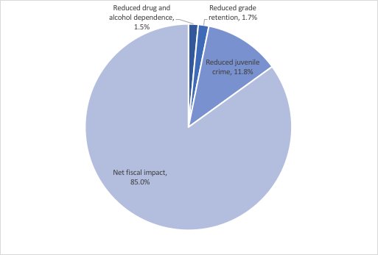
Figure 1: Breakdown of benefits from the base case return on investment by category.

What are other quantifiable benefits outside of the state/taxpayer perspective?
There are a variety of other potential benefits from investment in Georgia’s afterschool programs not included above. These include intangible benefits from improved school performance, reduced reliance on special education, increased future earnings, and reductions in juvenile crime, particularly for property crimes. Additional benefits for working parents include the provision of safe, supervised opportunities for their children, reduced anxiety during the hours after school, reduced distracting phone calls from children and caregivers, and may contribute to increased employee engagement (Corporate Voices for Working Families 2006).
Previous reviews have found that school intervention programs have a positive impact on student performance. In addition to the benefits achieved from improved productivity later in life due to higher graduation rates, students are also more likely to perform at grade level and less likely to need remedial or special education assistance that result in higher education costs. The reasons for this positive impact are often associated with an increase in school attendance, higher engagement in learning, and lower involvement in risky behaviors. For this analysis, the only short-term benefit that will be included results from reduced grade retention costs. There is no evidence of the impact of afterschool programming on special education placement and it will not be explicitly included in this analysis.

What would an additional investment in afterschool programming be likely to generate?
Table 4 provides estimates for expansion of CCLC and ACP programming, if the investment by the granting agency is matched by in-kind funding at the same rates as in this analysis. For example, the total cost used to arrive at $644 per student per year is based on a total cost of $63,966,774. This total includes $54,685,669 in grant funding ($551 per student) and $9,281,105 of financial in-kind funding and $43,154,519 of other in-kind services. Based on an additional $10 or $25 million in grant funding, the following might be expected in terms of additional participating students and net benefits to taxpayers. The total net benefit to taxpayers assumes the following for the students in the expanded sample of students as students in the current analysis:
- Regular participators and engagement level
- Elementary, middle, and high-school students
Table 4: Estimate of additional students and net benefits associated with additional afterschool funding.
Additional Grant Funding | Required Financial  In-Kind | Required  Other In-Kind | Additional Students | Net Benefit to Taxpayers
$10,000,000 | $1,697,173 | $7,891,376 | 18,164 | $61,503,304
$25,000,000 | $4,242,933 | $19,728,441 | 45,409 | $153,754,874

Sensitivity Analysis
Given that these estimates are based on other studies, it is important to conduct a sensitivity analysis to ensure that interpretation of the results are not primarily driven by any one assumption discussed above. Therefore, once the base case analysis was finalized, many of the parameters in the example calculations (Boxes 1 to 8) were varied to determine the impact of each on the baseline results. It is important to note that care was taken throughout this analysis to bias toward higher costs per student by taking into account “lost” costs on non-regular participators and an assumption that benefits are only realized to the fullest potential when a student participates fully through the program. Assumptions have been made the shift the costs of other participators in the program onto the students who are expected to benefit from the program. Further, assumptions have been made throughout the benefits estimation to bias toward a lower estimation of benefits. Therefore, the results found in this analysis are the lower bound and the actual net present value and benefit-cost ratio may be higher than what is presented.
Figure 2 plots the results of the variation of each parameter or assumption (as outlined in Boxes 1 to 8). The parameters/assumptions are ordered from most influential to least influential based on the relative impact on the NPV. These bars are centered on the baseline NPV of $3386. The result of the variation of each parameter/assumption did not cross the $0 threshold into a negative NPV (or BCR less than one). As noted in Box 2, an assumption was made for the base analysis that only 17.7% of the ACP in-kind donations and services were financial. Varying this assumption from 0% to 100% has the largest impact by the sensitivity analysis. With 100% of ACP in-kind categorized as financial, the NPV does become less than $0. The parameters or assumptions that directly affect the net fiscal impact were also influential. The discount rate affects costs or benefits that occur farthest into the future (beyond afterschool), which would be the net fiscal impact and had the largest influence of any parameter/assumption. This range of NPV from $634 to $6246 corresponds to a range of the BCR from $1.33 to $3.94. Further, any parameter/assumption related to the dropout rate (or eventual high school graduation) also indirectly impact the net fiscal impact as it depended on the difference between dropping out and completing high school.
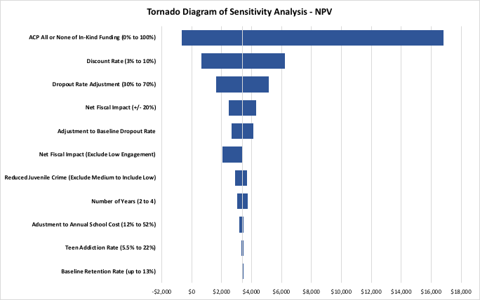
Figure 2: Tornado diagram plotting results of sensitivity analysis on the net benefits (relative to the base case analysis).

Even though the sensitivity analysis varied the parameters or assumptions in ways that would bias for and against afterschool programs having a positive NPV, the baseline analysis made assumptions that biased against afterschool programs having a positive NPV. Therefore, these lower bounds in Figure 2 (those with an NPV less than $3386) are highly unlikely, rather the upper bounds in the tornado diagram are far more likely to reflect any uncertainty around the baseline results. Further, if some parameters or assumptions might actually lead to a higher NPV, the combination of several of these parameters or assumptions would lead to even greater NPV than indicated above, for the potential of a NPV greater than $5000 and a BCR of $3.00 or larger (three dollars or more returned for each dollar invested).
One final consideration, one study found that afterschool programs positively reinforce early childhood intervention programs (Reynolds 2000), suggesting there is a benefit from afterschool programs separate from early childhood experiences to which these children may have been exposed.

Notes on Interpretation
It should be noted that these estimates are often based on numbers from early childhood intervention programs and preliminary estimates of the impacts of afterschool programs. The actual effects may be smaller or larger. The accuracy of these estimates is dependent on how closely the actual effects mirror the effects found by the existing studies. Accurate determination of the effects of these programs would require a detailed longitudinal study of participants and non-participants with similar backgrounds.
The costs of Georgia’s afterschool programs are borne exclusively by the taxpayers. The benefits, on the other hand, accrue to the individual and to society, and occur over the individual’s lifetime. We will calculate current dollar equivalents or prevent values for these costs and benefits. Our estimates may indicate that programs pay for themselves over time or may not.

Appendix

CCLC Data Summary
Two data files were provided by the Georgia Department of Education related to all fiscal year 2016 participants (the school year spanning 2015-2016) in Georgia’s CCLC programs. The first is a student information dataset and the second is a student assessment dataset with an ID number that connects students in the two files.

Afterschool Attendance
The number of days that students attended a CCLC afterschool program (combined across multiple programs if the student attended multiple programs that year) ranged from as few as one day to as many as 225 days. The average number of days attended was 67 days with a median of 55 days. Appendix Figure 1 shows the distribution of attendance across all participants in the dataset. A large proportion of students attend less than 25 days and other smaller attendance peaks near 115 and 130 days. The substantial number of students with attendance numbers greater than 180 days illustrates this includes programs run both during the school year and the summer.
For this analysis, students are categorized as regular participators if they attend at least 30 days of afterschool programming. Based on this attendance data there are 17,393 students that would be defined as regular participators. This is different from the number of regular attendees (same definition) reported in the 2016 Executive Summary of 20,637 (Georgia DOE 2016) because the data are from two different sources. Further, regular participators can be subdivided into low, medium, and high engagement levels (see Table 1 for definitions). Appendix Figure 2 shows the distribution across these engagement categories where none refers to all students not defined as regular participators. There are at least 3900 students in each engagement category and as engagement increases, the number of students in the category decreases.
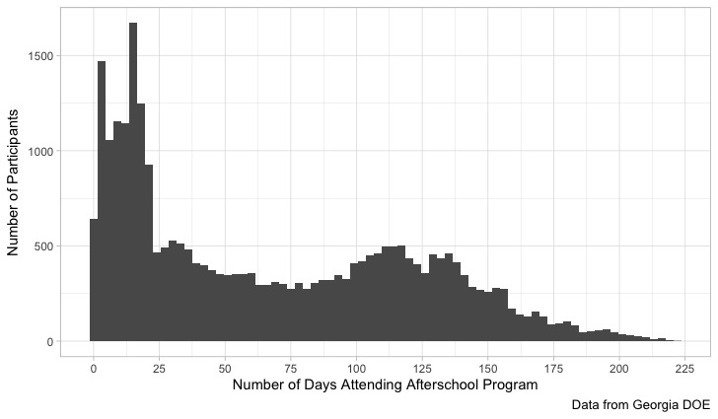
Appendix Figure 1: Histogram of days attending a CCLC afterschool program.

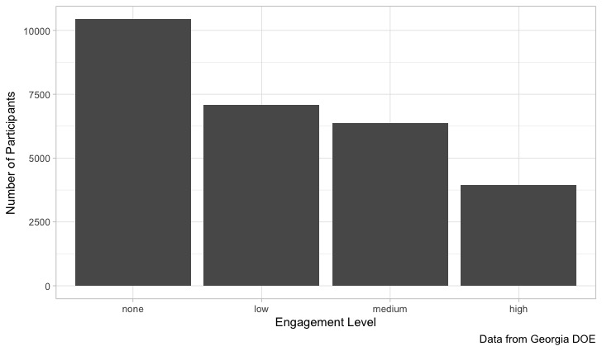
Appendix Figure 2: Histogram of student attendance by engagement level. None refers to all students not defined as regular participators.

School Day Attendance
Appendix Figure 3 shows the distribution of school attendance for all students in the dataset by total days present and total days absent. Most students were absent for less than 25 days. Almost half of all students were absent for fewer than 5 days (N = 13643, 49%) and 2996 had perfect attendance. Based on the following box plot of days absent, the largest numbers of days absent reported for participants are 124 and 100 with a smattering of observations between 75 and 100. Observations of days absent less than 75 days are more common.
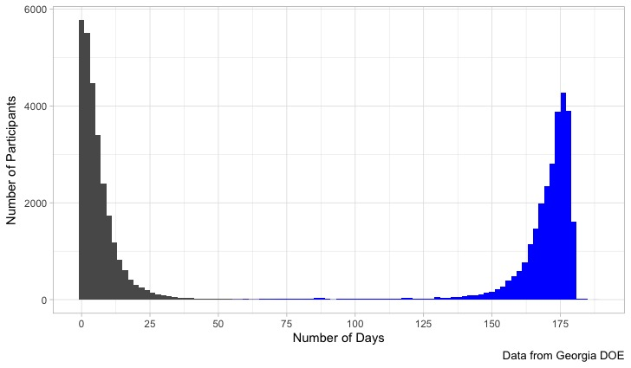
Appendix Figure 3: Histogram of days absent (in black) and days present (in blue) during the normal school day.

Being absent 15 or more days is used as the definition of chronically absent in the state of Georgia. Ten percent (N = 2897) of these students would be classified as chronically absent. Appendix Figure 4 shows a breakdown of the proportion of students absent within several different categories including five or fewer days, six to 15 days, and more than 15 days (for only the regular participators).
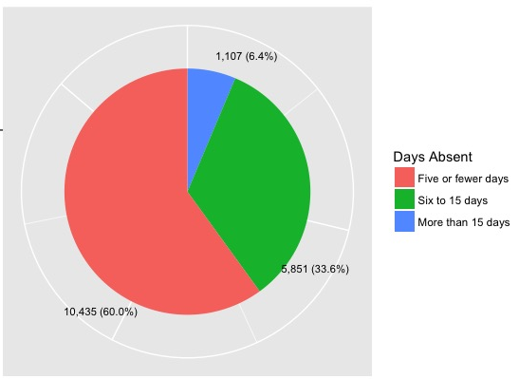
Appendix Figure 4: Pie chart of school day attendance absence categories.

The following two figures provide box and whisker plots for the number of days absent and the total days (days present plus days absent). Two students were absent for at least 100 days with a smattering of students absent more than 25 days. The total days figure shows that most students, as expected, have roughly 180 days either present or absent from school. However, there are quite a few students with total days of less than 180, to as low as nearly zero days. Students with fewer than 180 days were either at a school with the CCLC program for only part of the year or were not considered eligible participants for the entire school year. Because of the wide distribution of total days of school, percent of total days absent rather than number of days absent is likely a better overall indicator of school attendance.
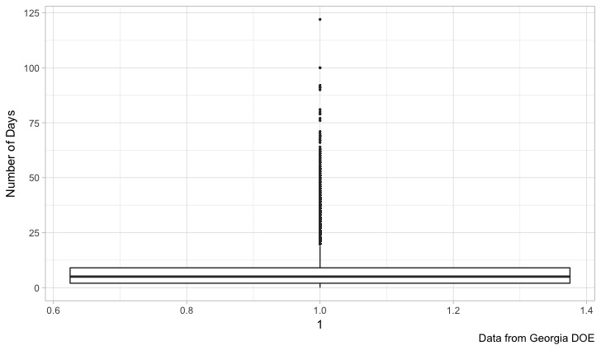
Appendix Figure 5: Distribution of days absent.

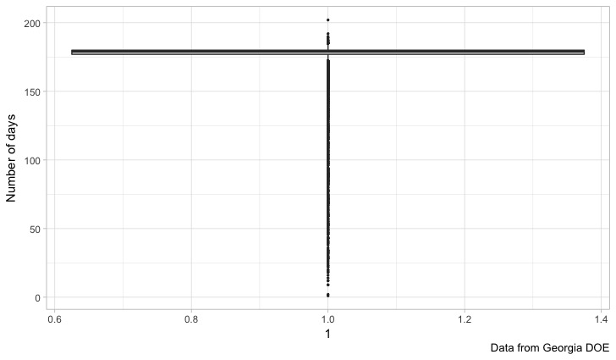
Appendix Figure 6: Distribution of total school days (days present plus days absent).

As the proportion of days absent is a better indication of school day attendance (or absence), Appendix Figure 7 provides a histogram of proportion of days absent, based on days of school reported in the CCLC data. Most students were absent for less than 10% of all possible days during the school year with few absent for more than 20% of all possible days.
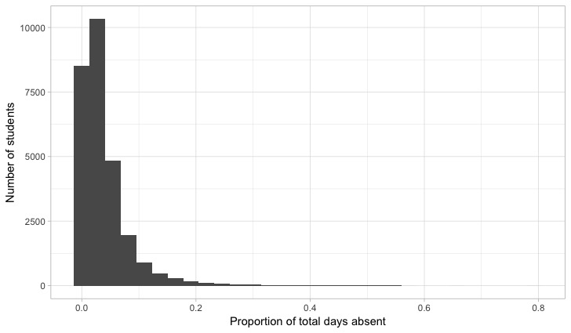
Appendix Figure 7: Histogram of proportion of days absent.

Based on Appendix Figure 8, the mean and median for the proportion of days absent does not vary significantly by grade level. However, slightly higher levels of absence are found in the youngest and oldest grades. Further, students with more than 40% of total days absent are primarily in the high school grade levels.
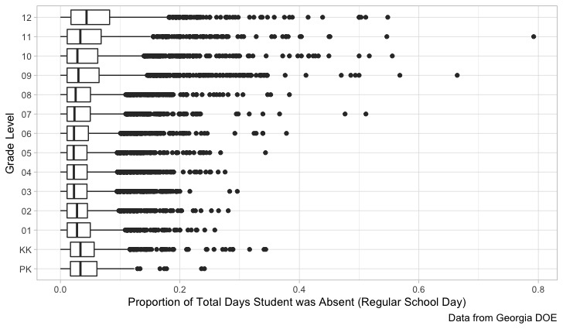
Appendix Figure 8: Proportion of days absent by grade level.

Grade Retention
The overall number of participating students retained for the 2016 school year is 2517 or 9% of all students in the CCLC sample. By comparison, the overall number of regular participating students retained for the 2016 school year is 1127 or 6% of all students in the CCLC sample. Appendix Figure 9 shows the proportion of students in the sample retained by grade level. The highest proportion of students retained is over 20% for ninth graders. All of the elementary grades are at or below the sample average of 9%. This is about four times as large as the 2.2% currently used in the methodology document.
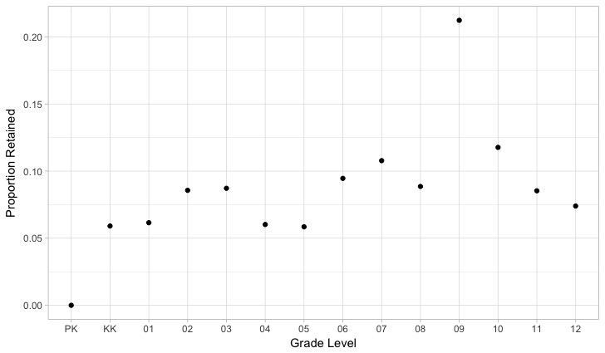
Appendix Figure 9: Proportion of students retained by grade level.

Assessment Results
Results of grade assessments are available for third through eighth graders and consist of two exams, English and Math. These are commonly referred to as “end of grade assessments” and are taken by most students in the state at the conclusion of elementary and middle school grades. Appendix Figure 10 shows the distribution of assessment performance for the English exam for third through eighth graders. The four categories of performance from lowest to highest are beginning (BEG), developing (DEV), proficient (PRO), and distinguished (DIS). Most students were not proficient on either the English or Math exams.
a)
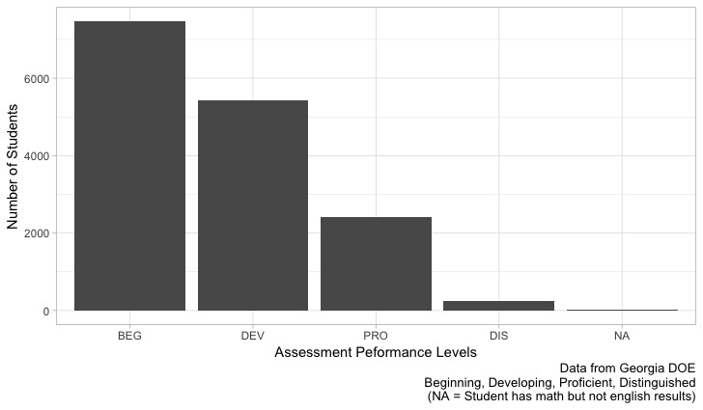
b)
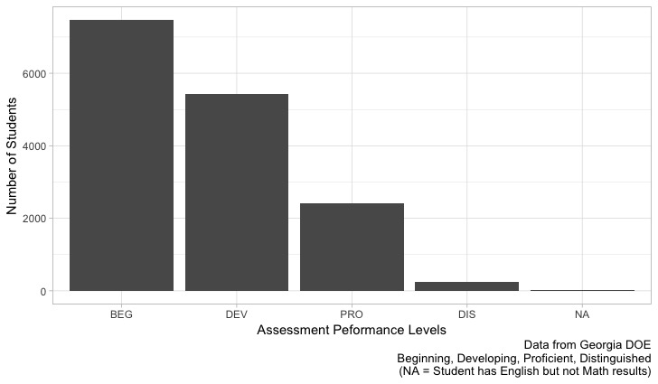
Appendix Figure 10: Distribution of students by performance level for a) English and b) Math end of grade assessments.

Analysis by Engagement Level
The following analyses consider how measures summarized above vary by participation or engagement level in an afterschool program. This study does not include a true control group but does include a large number of students that did not regularly participate in a program or participated at a low level of engagement. Significantly better attendance, lower retention, or higher assessment performance levels for medium and high engagement students may indicate potential impacts of the CCLC afterschool program.
First, there was no consistent variation in English or Math end of grade assessment performance by engagement levels as seen in Appendix Figure 11.
a)
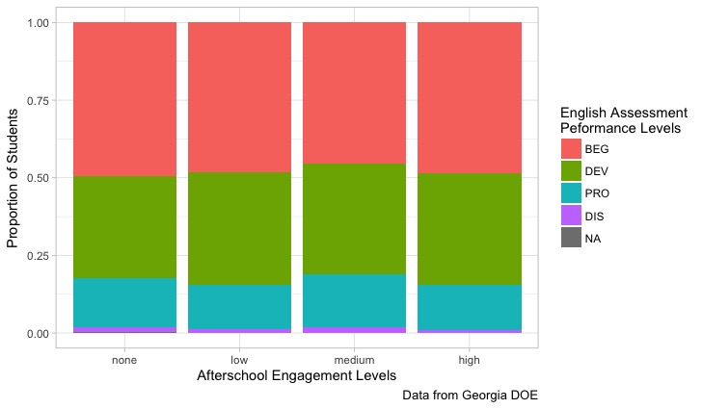
b)
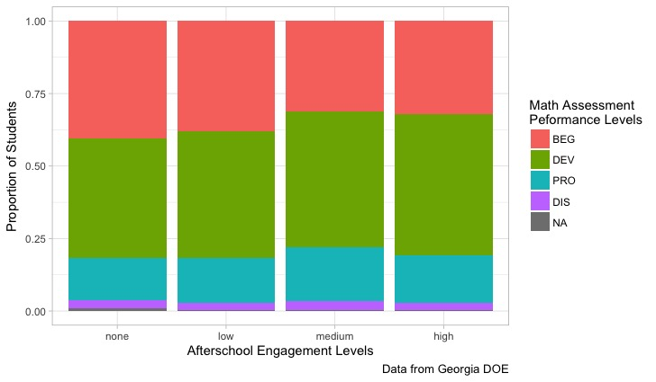
Appendix Figure 11: Distribution of students by performance across engagement level for a) English and b) Math end of grade assessments.

However, consistent variation was found in school day attendance and grade retention as the engagement level increased. Appendix Figure 12 shows that the average proportion of days absent decreases with increasing engagement level. For the highest engagement level, students were absent less than half as often as students that were not regular participators.
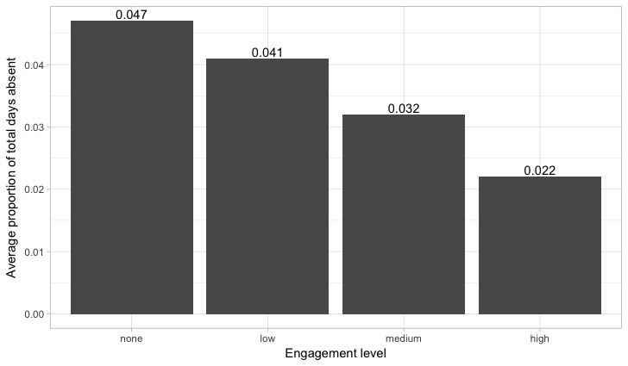
Appendix Figure 12: Average proportion of days absent by engagement level.

Appendix Figure 13 shows that the proportion of students retained decreases sharply as engagement level increases. Over 13% of students that were not regular participators were retained compared to less than 5% of those at a high engagement level. Low and medium engagement students were retained at 8% and 5.5%, respectively.
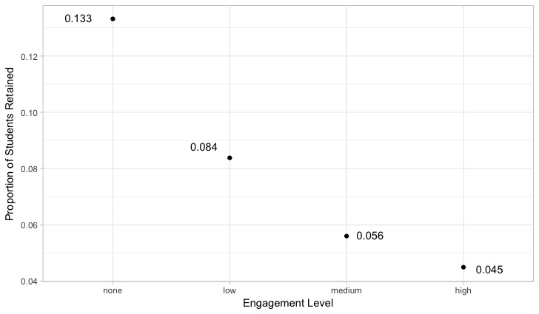
Appendix Figure 13: Grade retention by engagement level.

Bibliography
Bissell, J. and J. Malloy (2002). "Evaluation of California’s After-School Learning and Safe Neighborhoods Partnerships Program: 1999-2001." Irvine, Calif., February.

Brown, W. O., et al. (2002). "The costs and benefits of after school programs: The estimated effects of the after school education and safety program act of 2002." Claremont, CA: 1-43.

CASA (2011). "National study reveals: teen substance use America's #1 public health problem." Retrieved November 11, 2017, from https://www.centeronaddiction.org/newsroom/press-releases/national-study-reveals-teen-substance-use-america%E2%80%99s-1-public-health-problem.

Cohen, M. A. (1998). "The monetary value of saving a high-risk youth." Journal of Quantitative Criminology 14(1): 5-33.

Corporate Voices for Working Families (2006). Afterschool Toolkit: Community to Business.

Downey, M. (2016). Georgia trails national average in school spending. Should we invest more? Atlanta Journal Constitution. Atlanta, GA.

Georgia DOE (2016). 2015-2016 Executive Summary.

Georgia DOE (2017). Retrieved November 11, 2017, from https://gosa.georgia.gov/downloadable-data.

Georgia DOE (2017). Georgia's graduate rate increases for sixth straight year, tops 80 percent. 50 school districts' rates top 90 percent, Georgia Department of Education.

Goldschmidt, P., et al. (2007). The long-term effects of after-school programming on educational adjustment and juvenile crime: A study of the LA’s BEST after-school program. Los Angeles: UCLA/CRESST. Retrieved September. 8: 2008.

Lattimore, C., et al. (1998). "Blueprints for violence prevention, book four: Quantum Opportunities Program." Boulder, CO: Center for the Study and Prevention of Violence.

MOST Network (2014). Expanding opportunities, improving lives.

NCES (2017). "Indicator 14: Retention, Suspension, and Expulsion." Retrieved November 16, 2017, from https://nces.ed.gov/programs/raceindicators/indicator_rda.asp.

Newman, S. A., et al. (2000). "America's After-School Choice: The Prime Time for Juvenile Crime, or Youth Enrichment and Achievement."

OJJDP (2014). "OJJDP Statistical Briefing Book." Retrieved December 12, 2017, 2017, from http://www.ojjdp.gov/ojstatbb/offenders/qa03301.asp?qaDate=2010.

OJJDP (2016). "Juvenile Justice State Profile." Retrieved December 12, 2017, from http://www.ojjdp.gov/ojstatbb/stateprofile.asp.

Reynolds, A. J. (2000). Success in early intervention: The Chicago child parent centers, U of Nebraska Press.

Schweinhart, L. J. (1993). Significant Benefits: The High/Scope Perry Preschool Study through Age 27. Monographs of the High/Scope Educational Research Foundation, No. Ten, ERIC.

Sum, A., et al. (2009). "The consequences of dropping out of high school." Center for Labor Market Studies Publications 23.

