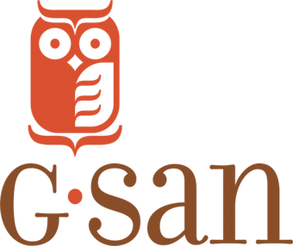

Georgia Statewide Afterschool Network
Afterschool Community Champions

Are you passionate about afterschool, summer, and other expanded learning programs? Would you like to learn how to turn that passion into action and be an advocate for Georgia’s children and families? If so, apply to join the Georgia Statewide Afterschool Network’s first cohort of Afterschool Community Champions and become one of our dedicated advocates for afterschool, summer, and expanded learning.

What: The Georgia Statewide Afterschool Network has launched an Afterschool Community Champion program where passionate afterschool supporters from across Georgia advocate for increased federal, state, and local support of afterschool and out-of-school time programs. Champions will work directly with GSAN to support statewide events and host events in their local communities.

Champions will receive advocacy training, free registration to the 2018 Afterschool and Youth Development Conference, membership to the Georgia E-learning Institute, and an event planning mini-grant.

When: The class of inaugural Afterschool Community Champions will be selected in January 2018.

Required Dates:
- January 16, 2018 – Welcome Lunch & Advocacy Training
- February 28, 2018 – Afterschool Provider Day at the State Capitol
- April 19, 2018 – Afterschool for All Challenge
- July 12, 2018 – Host a Summer Learning Day
- October 25, 2018 – Host a Lights On Afterschool Day
- Monthly Champion Update Calls

How to Apply:
Please fill out our Champions application here. Don’t hesitate to email Sharnae, GSAN’s AmeriCorps VISTA, with any questions you may have about the program or the application. Applications are open until Friday, December 8.

